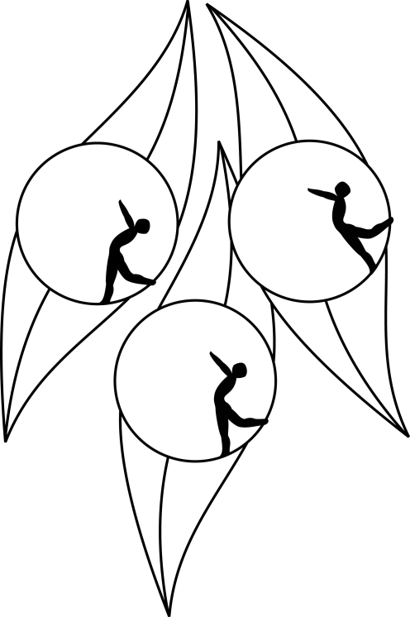
SOUTH AUSTRALIAN ICE SKATING ASSOCIATION Inc.

Results

TEST SESSION

16 March 2011
Ice Arena, Thebarton

Congratulations to the following skaters:

Junior
Amy Newbery

Novice
Madison Murray

Primary
Alyce Skeates

Primary Pairs
Rhianon Reese & Joshua Broad

